**Section 2.8**

2. A graph of a function is given. Determine whether is one-to-one.



~~~~~~~~~~~~~~~~~~~~~~~~~~~~~~~~~~~~

4. Determine whether the functions are one-to-one.

a.

b.

~~~~~~~~~~~~~~~~~~~~~~~~~~~~~~~~~~~~

6. Assume that is a one-to one function. If , find .

~~~~~~~~~~~~~~~~~~~~~~~~~~~~~~~~~~~~

8. If , find .

~~~~~~~~~~~~~~~~~~~~~~~~~~~~~~~~~~~~

1. A graph of a function is given. Determine whether is one-to-one.



~~~~~~~~~~~~~~~~~~~~~~~~~~~~~~~~~~~~

Yes, is one-to-one because it passes the horizontal (and vertical) line test.

3. Determine whether the functions are one-to-one.

a.

b.

~~~~~~~~~~~~~~~~~~~~~~~~~~~~~~~~~~~~

a. Yes, because it passes the horizontal line test since its graph looks like the typical square root function except horizontally shrunk.

b. No, because it does not pass the horizontal line test since its graph is a parabola that opens up.

5. Assume that is a one-to one function. If , find .

~~~~~~~~~~~~~~~~~~~~~~~~~~~~~~~~~~~~

Since that means the point (2, 9) is on function . Since is one-to-one the point (9, 2) is on . Therefore, .

7. If with , find .

~~~~~~~~~~~~~~~~~~~~~~~~~~~~~~~~~~~~

By guess and check or by using a graphing calculator, I find that . That means the point (5, 75) is on the function and the point (75, 5) is on . Therefore, .

9. A graph of a function is given. Use the graph to find the indicated values.



a.

b.

~~~~~~~~~~~~~~~~~~~~~~~~~~~~~~~~~~~~~

a.

b.

11. A table of values for a one-to-one function is given. Find the indicated value.



~~~~~~~~~~~~~~~~~~~~~~~~~~~~~~~~~~~~~~

13. Find the inverse function of .

a.

b.

~~~~~~~~~~~~~~~~~~~~~~~~~~~~~~~~~~~~~~

a.

b.

10. A graph of a function is given. Use the graph to find the indicated values.



a.

b.

~~~~~~~~~~~~~~~~~~~~~~~~~~~~~~~~~~~~~

12. A table of values for a one-to-one function is given. Find the indicated value.



~~~~~~~~~~~~~~~~~~~~~~~~~~~~~~~~~~~~~

14. Find the inverse function of .

a.

b.

~~~~~~~~~~~~~~~~~~~~~~~~~~~~~~~~~~~~~~

12. Express the function in the form . There is more than one correct answer. The function is of the form . Use non-identity function for and .

a.

b.

~~~~~~~~~~~~~~~~~~~~~~~~~~~~~~~~~~~~~~

16. Find the inverse function of .

a. ,

b. ,

~~~~~~~~~~~~~~~~~~~~~~~~~~~~~~~~~~~~~

18. The given function is not one-to-one. Restrict its domain so that the resulting function is one-to-one.

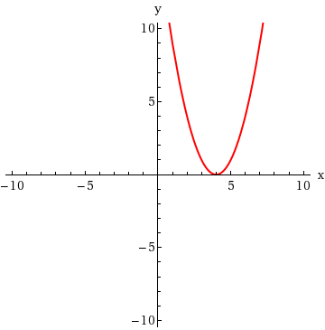

~~~~~~~~~~~~~~~~~~~~~~~~~~~~~~~~~~~~~~

12. Express the function in the form . There is more than one correct answer. The function is of the form . Use non-identity function for and .

a.

b.

~~~~~~~~~~~~~~~~~~~~~~~~~~~~~~~~~~~~~~

15. Find the inverse function of .

a. ,

b.

~~~~~~~~~~~~~~~~~~~~~~~~~~~~~~~~~~~~~

a. ,

, ,

, ,

, ,

, ,

, ,

, ,

b.

, ,

, ,

, ,

, ,

, ,

,

,

17. The given function is not one-to-one. Restrict its domain so that the resulting function is one-to-one.

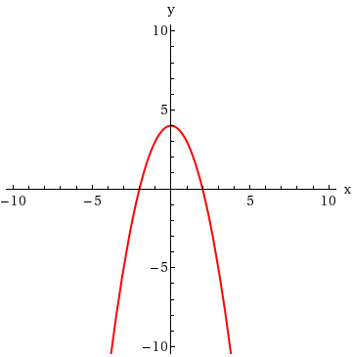

~~~~~~~~~~~~~~~~~~~~~~~~~~~~~~~~~~~~~~

There are a lot of ways (infinitely many to be exact) of restricting the domain so the function is one-to-one. Since its graph is a parabola you need to restrict the domain so you only have the right side, part of the right side, the left side, or part of the left side. For example, , , , , etc.